EUROPEAN MEDIA ART FESTIVAL
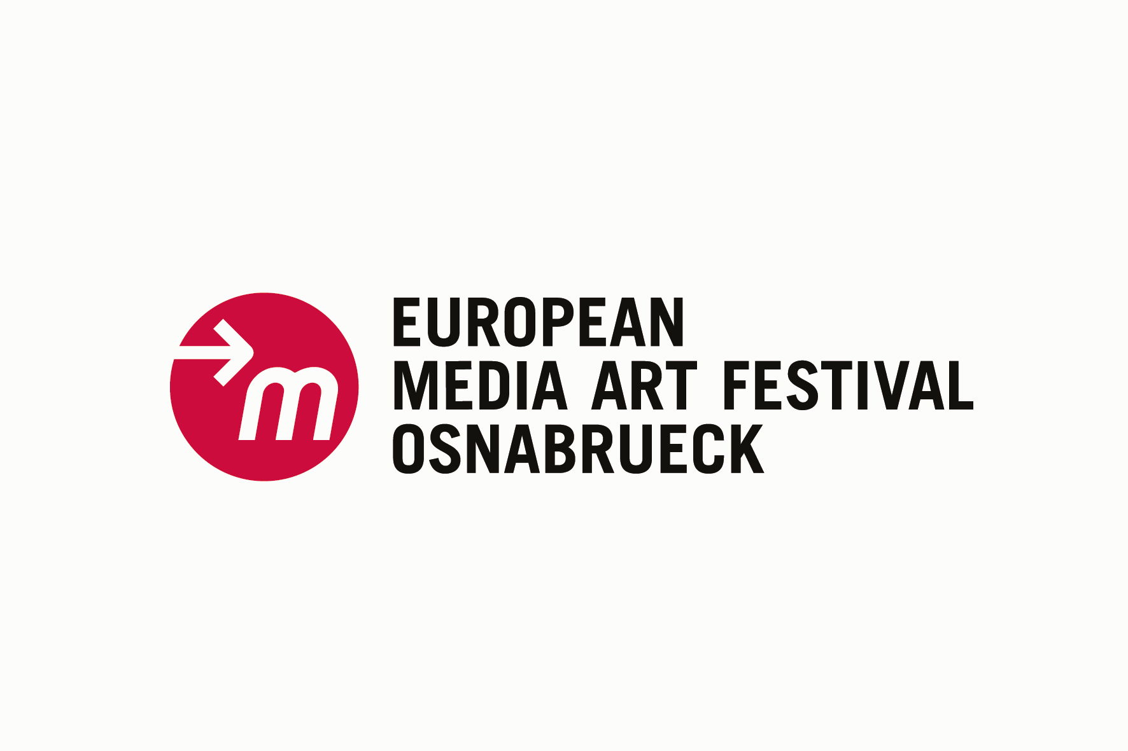
Experimentalfilm Workshop e.V.
Lohstraße 45a
D-49074 Osnabrück
Tel.: +49 (0)541 21658
Fax: +49 (0)541 28327
www.emaf.de

PRESS RELEASE – please publish!

25th European Media Art Festival, 18 – 22 April 2012
Exhibition: 18 April – 27 May 2012

Current Media Art – also to mark 25 years of EMAF in Osnabrück

This year, Osnabrück’s European Media Art Festival will celebrate its 25th anniversary. But instead of getting melancholic and retrospective, it will instead focus once again on the latest trends in experimental Media Art from 18 to 22 April.

Over 2,300 entries from artists around the world are piled up high, waiting to be viewed. The film/video jury this year consists of Erwin van ’t Hart, Film Festival Rotterdam, Alex Gerbaulet, Braunschweig University of Art, Philipp Czogalla, University of Paderborn and Helene Webers, SMART Project Space Amsterdam. Under the direction of Ralf Sausmikat, an extremely diverse festival programme will be created over the next few weeks, a programme with a wide range of shorts and feature-length films to really entertain visitors to the festival and to stimulate controversial discussions. It took only a few days of viewing for the jury to realise that this year’s programme would contain numerous longer films; they were impressed by many 30- to 40-minute works.
In the exhibition area of the festival, visitors will be able to experience monitor installations, kinetic objects and light art projects in addition to sound walks and interactive feature films: equipped with a smartphone, visitors can explore sound spaces in the city or design a film together with others.

It goes without saying that the upcoming festival will also take a look back at the 25-year history of EMAF. Internationally renowned artists whose earliest works screened at EMAF years ago will present their current productions, addressing the subject of the every-changing methods used in Media Art.

EMAF designated a “Selected Landmark 2012”

As a fitting tribute to its anniversary, EMAF has received a commendation:
the festival has been nominated a “Selected Landmark 2012”. As a forum of the international media art world, therefore, it is one of the prize-winners of the “365 Landmarks in the Land of Ideas” competition, run by the nation-branding initiative “Germany – Land of Ideas” in cooperation with Deutsche Bank.
Each year the initiative, under the patronage of the German President, rewards outstanding projects and ideas each year that make a lasting contribution to Germany’s future viability. As one of the prize-winners, EMAF is therefore an “Ambassador for the Land of Ideas” in 2012, and represents Germany’s innovative potential.
The award ceremony will be held in the Kunsthalle Dominikanerkirche on 20 May 2012, on the occasion of International Museum Day.

For the latest information on the festival, visit www.emaf.de or check out facebook, twitter, vimeo and flickr.

European Media Art Festival

The EMAF in Osnabrück is one of the most important forums of international Media Art, and is an open laboratory for creative and artistic experiments that help shape media and the aesthetics of their content. As a lively meeting place for artists, curators, lenders, gallery owners and a specialist audience, it has been instrumental in forming the themes and aesthetics of Media Art.

// CONCEPT AND FESTIVAL MANAGEMENT
Hermann Nöring, Alfred Rotert, Ralf Sausmikat

// FÖRDERER
nordmedia - Die Mediengesellschaft Niedersachsen/Bremen mbH
Stadt Osnabrück
Bundesministerium für Bildung und Forschung
Auswärtiges Amt
Stiftung Niedersachsen
Europa fördert Niedersachsen
Europäischer Fonds für regionale Entwicklung
CIP-ICT Policy Support Programme of the EU
Universität Osnabrück
Embassy of Canada

// MEDIA PARTNERS
arte creative
le monde diplomatique

// CULTURAL PARTNERS
NDR Kultur

// MORE INFORMATION

Kerstin Kollmeyer
Presse(at)emaf.de
European Media Art Festival
Lohstr. 45a
D-49074 Osnabrück
Tel. +49 (0)541/216 58
Fax +49 (0)541/ 28327
www.emaf.de

