EUROPEAN MEDIA ART FESTIVAL
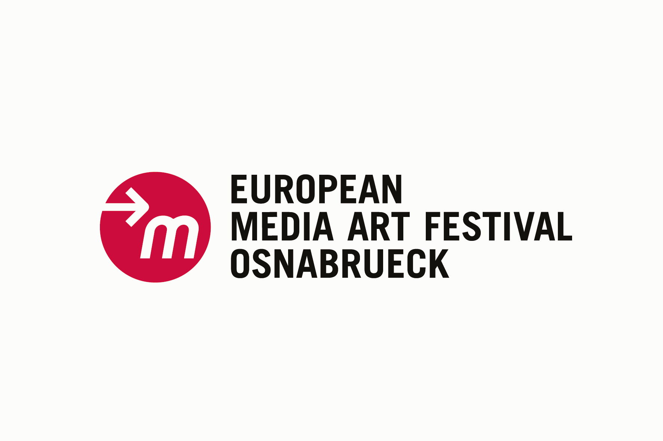
Experimentalfilm Workshop e.V.
Lohstraße 45a
D-49074 Osnabrück
Fon: +49 (0) 541 21658
Fax: +49 (0) 541 28327
www.emaf.de

Press release about the festival – please publish!

24th European Media Art Festival, 27 April – 1 May 2011
Exhibition 27 April – 29 May 2011

Media Art and Melancholy

A change of thinking has long taken place: natural disasters, wars and the disappointed belief in technology are increasingly making us contemplative, changing our perception. This was revealed at the 24th European Media Art Festival (EMAF), which took place in Osnabrück between 27 April and 1 May. The festival was more political this year. Festival directors Hermann Nöring, Alfred Rotert and Ralf Sausmikat took stock of the event.

“A new manner of considering nature is emerging,” explains Hermann Nöring. “This time, many projects focused on critically exploring technological promises.” Stories are increasingly being told that are often marked by a melancholy undertone. The narrative level is very distinct at this year’s Media Art exhibition. Which is why “Moving Stories” is the title of part of the exhibition “Planet M”, which can be visited at the Kunsthalle Dominikanerkirche until the end of May.

The video and film programme also reveals a very clear tendency: “Narrative, documentary and socially relevant approaches prevail,” finds Ralf Sausmikat. Utopian, social-political concepts of social justice and the belief in the good of technical progress are increasingly giving way to a distanced/sceptic view of the future. This special method of transporting subject matter and exploring a loss of utopia emerges as the lowest common denominator this year.

The media are obliterating distances, enabling us to experience events directly, even if they take place on the other side of the globe. “Contemporary art has always been a kind of seismograph for societal, political and social developments,” explains Alfred Rotert. Due to the wars in Iraq, Afghanistan and Libya, following the natural disasters in Indonesia and on Haiti, with the issue of the climate and the latest events in Japan, the system of coordinates of belief in an ever improving civilisation has gone haywire in the western world.

The exhibition reflects this dominating feeling of loss and doubt: “Images from nature no longer serve as romantic backdrop, but are presented as uninhabited, self-sufficing landscapes with dynamics of their own,” states Nöring. Violence and the destruction of culture, as well as a lack of environments suitable for children are also addressed. The view of poverty and of ethnic marginalisation or of general political impotence is by all means dominant.

“We are already eager to see what 2012 holds,” the organisers agree. “One thing for sure is that Media Art will respond to the events occurring on earth and will retain its function as a mouthpiece of society and as a mirror of political events!” the festival management concludes.

European Media Art Festival

The EMAF in Osnabrück is one of the most important forums of international Media Art, and is an open laboratory for creative and artistic experiments that help shape media and the aesthetics of their content.
As a lively meeting place for artists, curators, lenders, gallery owners and a specialist audience, it has been instrumental in forming the themes and aesthetics of Media Art.

// CONCEPT AND FESTIVAL MANAGEMENT
Hermann Nöring, Alfred Rotert, Ralf Sausmikat.

// SPONSORS
nordmedia - Die Mediengesellschaft Niedersachsen/Bremen mbH
City of Osnabrück
German Federal Ministry of Education and Research
German Federal Foreign Office
Kulturstiftung des Bundes
Kulturstiftung der Länder
Foundation of Lower Saxony
Europa fördert Niedersachsen
European Regional Development Fund
EU/Culture Programme
150 Years of Friendship Germany - Japan
University of Osnabrück
Mondriaan Foundation
Canadian Embassy
Grenswerte, funded by Euregio
Cybob Communications

// MEDIA PARTNERS
arte
le monde diplomatique

// CULTURAL PARTNERS
NDR Kultur

// MORE INFORMATION

Kerstin Kollmeyer
Presse(at)emaf.de

European Media Art Festival
Lohstr. 45a
D-49074 Osnabrück
Tel. +49 (0)541/216 58

Fax +49 (0)541/ 28327

